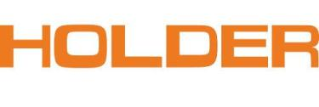
PRESS-INFORMATION
Max Holder GmbH
Max-Holder-Straße 1
D-72555 Metzingen

Contact: ontakt:
Franziska Reiche
Tel.: +49 7123 966-281
f.reiche@max-holder.com

Metzingen, 01.04.2014

Holder presents system solutions for
year-round use at IFAT 2014

At the world's leading trade fair for water, sewage, waste and raw materials management in Munich the pioneer of articulated steering shows technically and economically convincing solutions for service providers and municipal users.

When on March 5th 2014 the gates of Munich Exhibition open, visitors can expect a wide range of articulated implement carriers at Holder stand C335 in hall C3: machines with 27-92 HP, equipped with modern comfort cabins and a wide variety of attachments, impressively convey the performance of the Holder system.

In addition to a Holder C 270 with complete winter service equipment and a Holder S 990 with water barrel, reach arm mower and washing brush, especially the new Holder X 30 is expected to draw attention to itself: with sweeping suction unit, mower, watering arm and the unique X³ hopper for debris, grass and water, it is an attractive demonstration of the innovative power of the traditional German company. Holder is supported at the IFAT by its attachments partners Bema, Dücker, Kahlbacher and Kugelmann.

About Max Holder GmbH
Max Holder GmbH is a renowned manufacturer of multi-functional tractors with articulated steering for municipal applications as well as for viticulture and fruit production. Whether lawn care, walkway cleaning, transportation tasks, earth movement, plant protection, greenery work, winter road maintenance, or numerous special applications – customers in many countries rely on the Holder brand. The traditional company from Metzingen, Germany, which was established in 1888, offers complete solutions and services from a single source: multi-functional carrier vehicles, suitable attachment technology, individual services and flexible rental concepts.

Photo (1): Holder
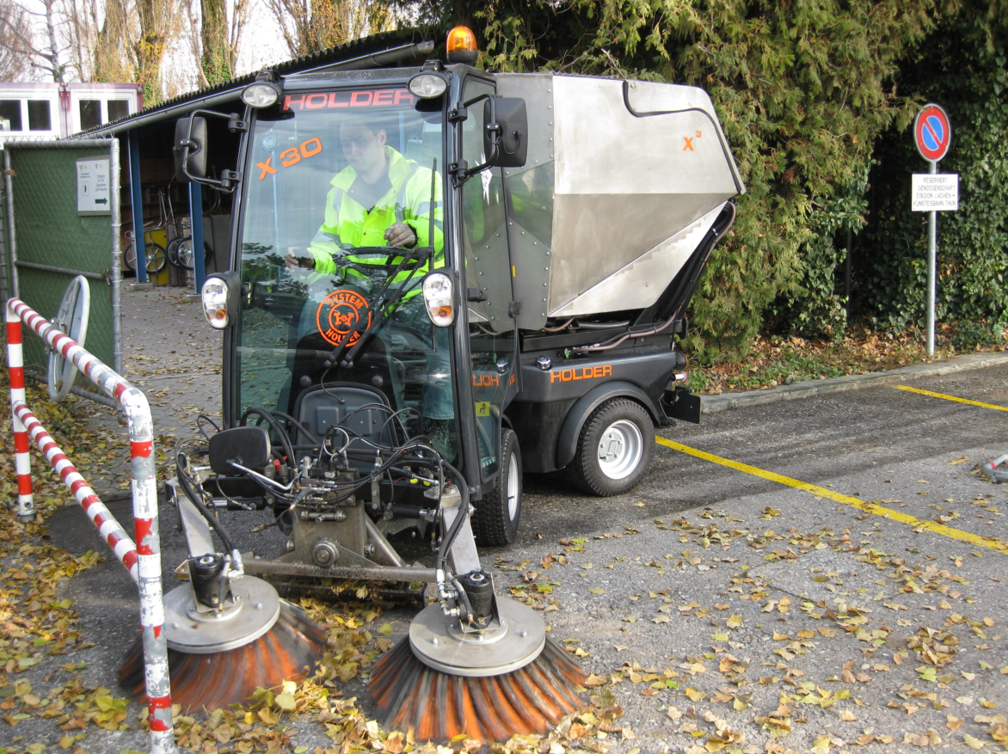
Holder X 30 (27 HP) with sweeping suction unit

